Could John Wilkes Booth Have Committed
Suicide at Garrett’s Farm?
by
Joseph E. “Rick” Smith III and William L. Richter

It is a familiar story told repeatedly by historians. Early on the morning of April 26, 1865, noted actor John Wilkes Booth, the man who assassinated President Abraham Lincoln, was shot while in a blazing tobacco barn on the farm of Richard Garrett near Port Royal, Virginia. Rescued from the fire by the Union cavalrymen who had pursued him, Booth was removed to the Garrett’s front porch where he died just after dawn, paralyzed below the neck, his nerves severed by the bullet that had passed through his cervical spine, asphyxiated by the fluids that his failing heart could no longer remove from his lungs.
Even before Booth died, the question arose as to who killed him. History tells us it was Sergeant Boston [born Thomas H.] Corbett from Company L of the 16th New York Volunteer Cavalry. A self-castrated religious mystic, Corbett came forward (“Who fired that shot?”) and told his commanding officer and the two civilian detectives with him, that he fired contrary to orders to take Booth alive, because he believed that Booth was about to shoot one of them. As Corbett succinctly put it: “Providence directed my hand.”
But did He? Or did the Almighty direct some other “hand” to commit the deed? Evidently Lt. Byron Baker and Lt. Col. Everton Conger, the two detectives from Col. Lafayette C. Baker’s National Detective Police leading the cavalry patrol, thought so. Each accused the other of shooting Booth, even though they could not see each other when the shot was fired. Conger then concluded that Booth might have shot himself. Baker demurred and opined that the man who shot Booth ought to go back to the District under arrest for violating orders. Despite Corbett’s confession as to being the shooter, he was not arrested. Indeed, he became a hero.
But the actual account is not as simple as modern commentators would like us to believe. As pointed out by historian H. Donald Winkler, there are at least four scenarios that could have taken place at the Garrett’s tobacco barn. First, Booth shot himself. No one really examined Booth’s weapons to see if one of the revolvers had been fired, even though Baker had to twist one revolver from the fallen actor’s hand. Booth had told Willie Jett, one of the Confederate soldiers who brought him to Garrett’s, that he would not be taken alive to be marched through Washington like some Roman captive from centuries before. Others who are against this theory point out that Booth had a carbine in his right hand and a crutch under his left arm. But Col. Conger said that Booth had thrown down the crutch and had the carbine in both hands. The only weapon inspected after the fight was the carbine, which was done at Secretary Stanton’s bidding. It was found to have a cartridge jammed in its breech. Hence Booth’s desperate need for a properly functioning weapon casts doubt on Private Emory Parady’s statement that the actor was too loaded down with extraneous items in his hands to have committed suicide.
Second, some thought that Conger was the one who shot Booth under orders from Union Secretary of War Edwin McMasters Stanton. He and Baker argued the point at the door when Conger returned from starting the fire that eventually gutted the barn. But how could Conger have shot an upright Booth in such a manner as to cause the bullet to travel downward through the neck, unless Booth was bent over? The same problem faces us in the third scenario, that Corbett shot Booth. Again, to achieve the proper trajectory, Booth had to be bent over sideways from the waist. He was an athlete, not a contortionist. There is also another problem with the theory that Corbett made the shot. Researcher Col. Julian E. Raymond, a combat veteran of World War II, maintains that Corbett and the other troopers were armed with carbines, not pistols. Booth was wounded by a ball fired from a .44 caliber handgun as opposed to the standard .52 caliber carbine round.
Fourth, it is possible that someone completely unrelated to the pursuing Federals shot Booth. Winkler believes that Booth was headed toward Milford Station to join up with Col. John S. Mosby’s command. The three Confederate soldiers who had guided him from Port Royal to Garrett’s farm were members of Mosby’s command. Another Confederate soldier home from the war, Enoch Mason, had ridden the ferry across the Rappahannock with Booth, his companion David E. Herold, and the three Confederate cavalrymen. Mason had immediately galloped out of Port Royal southward upon landing. The suspicion is that he went to inform Mosby of Booth’s presence. Several local boys home from the war were present at dinner at Garrett’s the day before Booth was shot. If they were informed of the presence of Union troops on the road past Garrett’s, it may have been decided that Booth had to be killed to prevent him from talking and telling all he knew of the plots against Lincoln, be they abduction or assassination.
The most recent approach as regards who shot Booth is an article by Blaine V. Houmes and Steven G. Miller, which asserts that Booth committed “suicide by cop.” Not an unheard of concept nowadays, and becoming more popular or perhaps more notable, theirs is the notion that a malefactor unable to commit his own suicide forces the police to shoot by threatening them with a weapon. In Booth’s case, if this is so, he becomes one of the first to be so categorized. One does have some misgivings that, given the weapons available in 1865, Booth was taking a great chance at being horribly wounded, which is exactly what happened, rather than instantly killed.
Houmes and Miller are probably correct in theorizing that Booth wanted to commit suicide by cop. Historian James L. Swanson related how Booth dared the Yankees to back off 100 yards and form a skirmish line and that he would come out of the barn and take them all on. Swanson correctly understands the Booth mind-set when he compares this to a Shakespearean drama or perhaps a knight jousting at a medieval tournament, throwing down the gauntlet to any who would accept his challenge, romanticism versus realism. Booth later gallantly halved the distance and offered to do combat at fifty yards. But the Union officers were not about to allow Booth the chance to kill or wound any of their men. Besides, they wanted Booth alive. Secretary of War Stanton had so willed it. In Booth’s mind the Union men had no pride, realism versus romanticism.
This stance of the cavalry patrol commanders put Booth in a quandary. He had to surrender and face arrest and an eventual hanging for killing Lincoln. Or he could end the whole thing immediately by committing suicide. It was a choice Booth addressed in a typically Southern fashion—humiliation or honor. These things were important in the Old South—or to medieval England and its chronicler, the playwright William Shakespeare, whom Booth and his neighbors revered. In our mind, Booth did that which had to be done. It was already scripted; he had penned it in his diary: “Who can read his fate? God's will be done. I have too great a soul to die like a criminal. Oh, may He, may He spare me that, and let me die bravely." Booth simply decided to blow his brains out. But in throwing down his carbine and crutches and drawing his revolver, he underestimated the weakness of his broken leg and the weight of the weapon’s barrel. Instead of shooting himself behind the ear, he stepped forward, wincing in pain and off balance, the barrel sliding down his neck as he fired, mortally wounding himself.
But, all this is debatable theory. The question remains: was Booth physically able to have committed suicide in such a way as to produce the type of wound from which he subsequently died? Noted assassination authority, Dr. John K. Lattimer, makes much of the fact that Booth could not have shot himself, because the "long-barreled" 1860 Colt's Army Model revolver was too heavy for Booth to manipulate to get his thumb on the trigger without using both hands. He was encumbered with the Spencer carbine or his crutch or both in his left hand. Moreover, Lattimer asserts, Booth could not have produced the angle of the bullet's path if he fired the gun with his thumb because his arm being held at his side would have prevented it.
If Booth had tried to shoot himself with his index finger on the trigger, as a handgun is normally held and fired, Lattimer continues, Booth could not have reproduced the proper angle of the shot either. Lattimer made use of photographs to illustrate his point regarding the impossibility of Booth inflicting the wound, which he sustained. In the photos, he has his demonstrator hold the weapon to his head with his elbow held down and close to his side. If one holds the gun as Lattimer shows one ought, his story is correct. But, that is not the way a skilled shooter would do it. Rather than holding the weapon with our elbow at our side, we held it as any man familiar with firearms, as Booth was, with our elbow out to the side and above our shoulder height. The revolver is held as normal, but with the barrel down and the handgrip up. It is possible in this manner not only to duplicate the angle and trajectory of Booth's wound, but almost any angle one wishes to achieve. The barrel is long, but not that long. Again, moving the elbow out away from one's side and holding it at shoulder height or above allows one to produce almost any angle of bullet path. And it can easily be done one-handed, without changing the normal grip on the revolver.

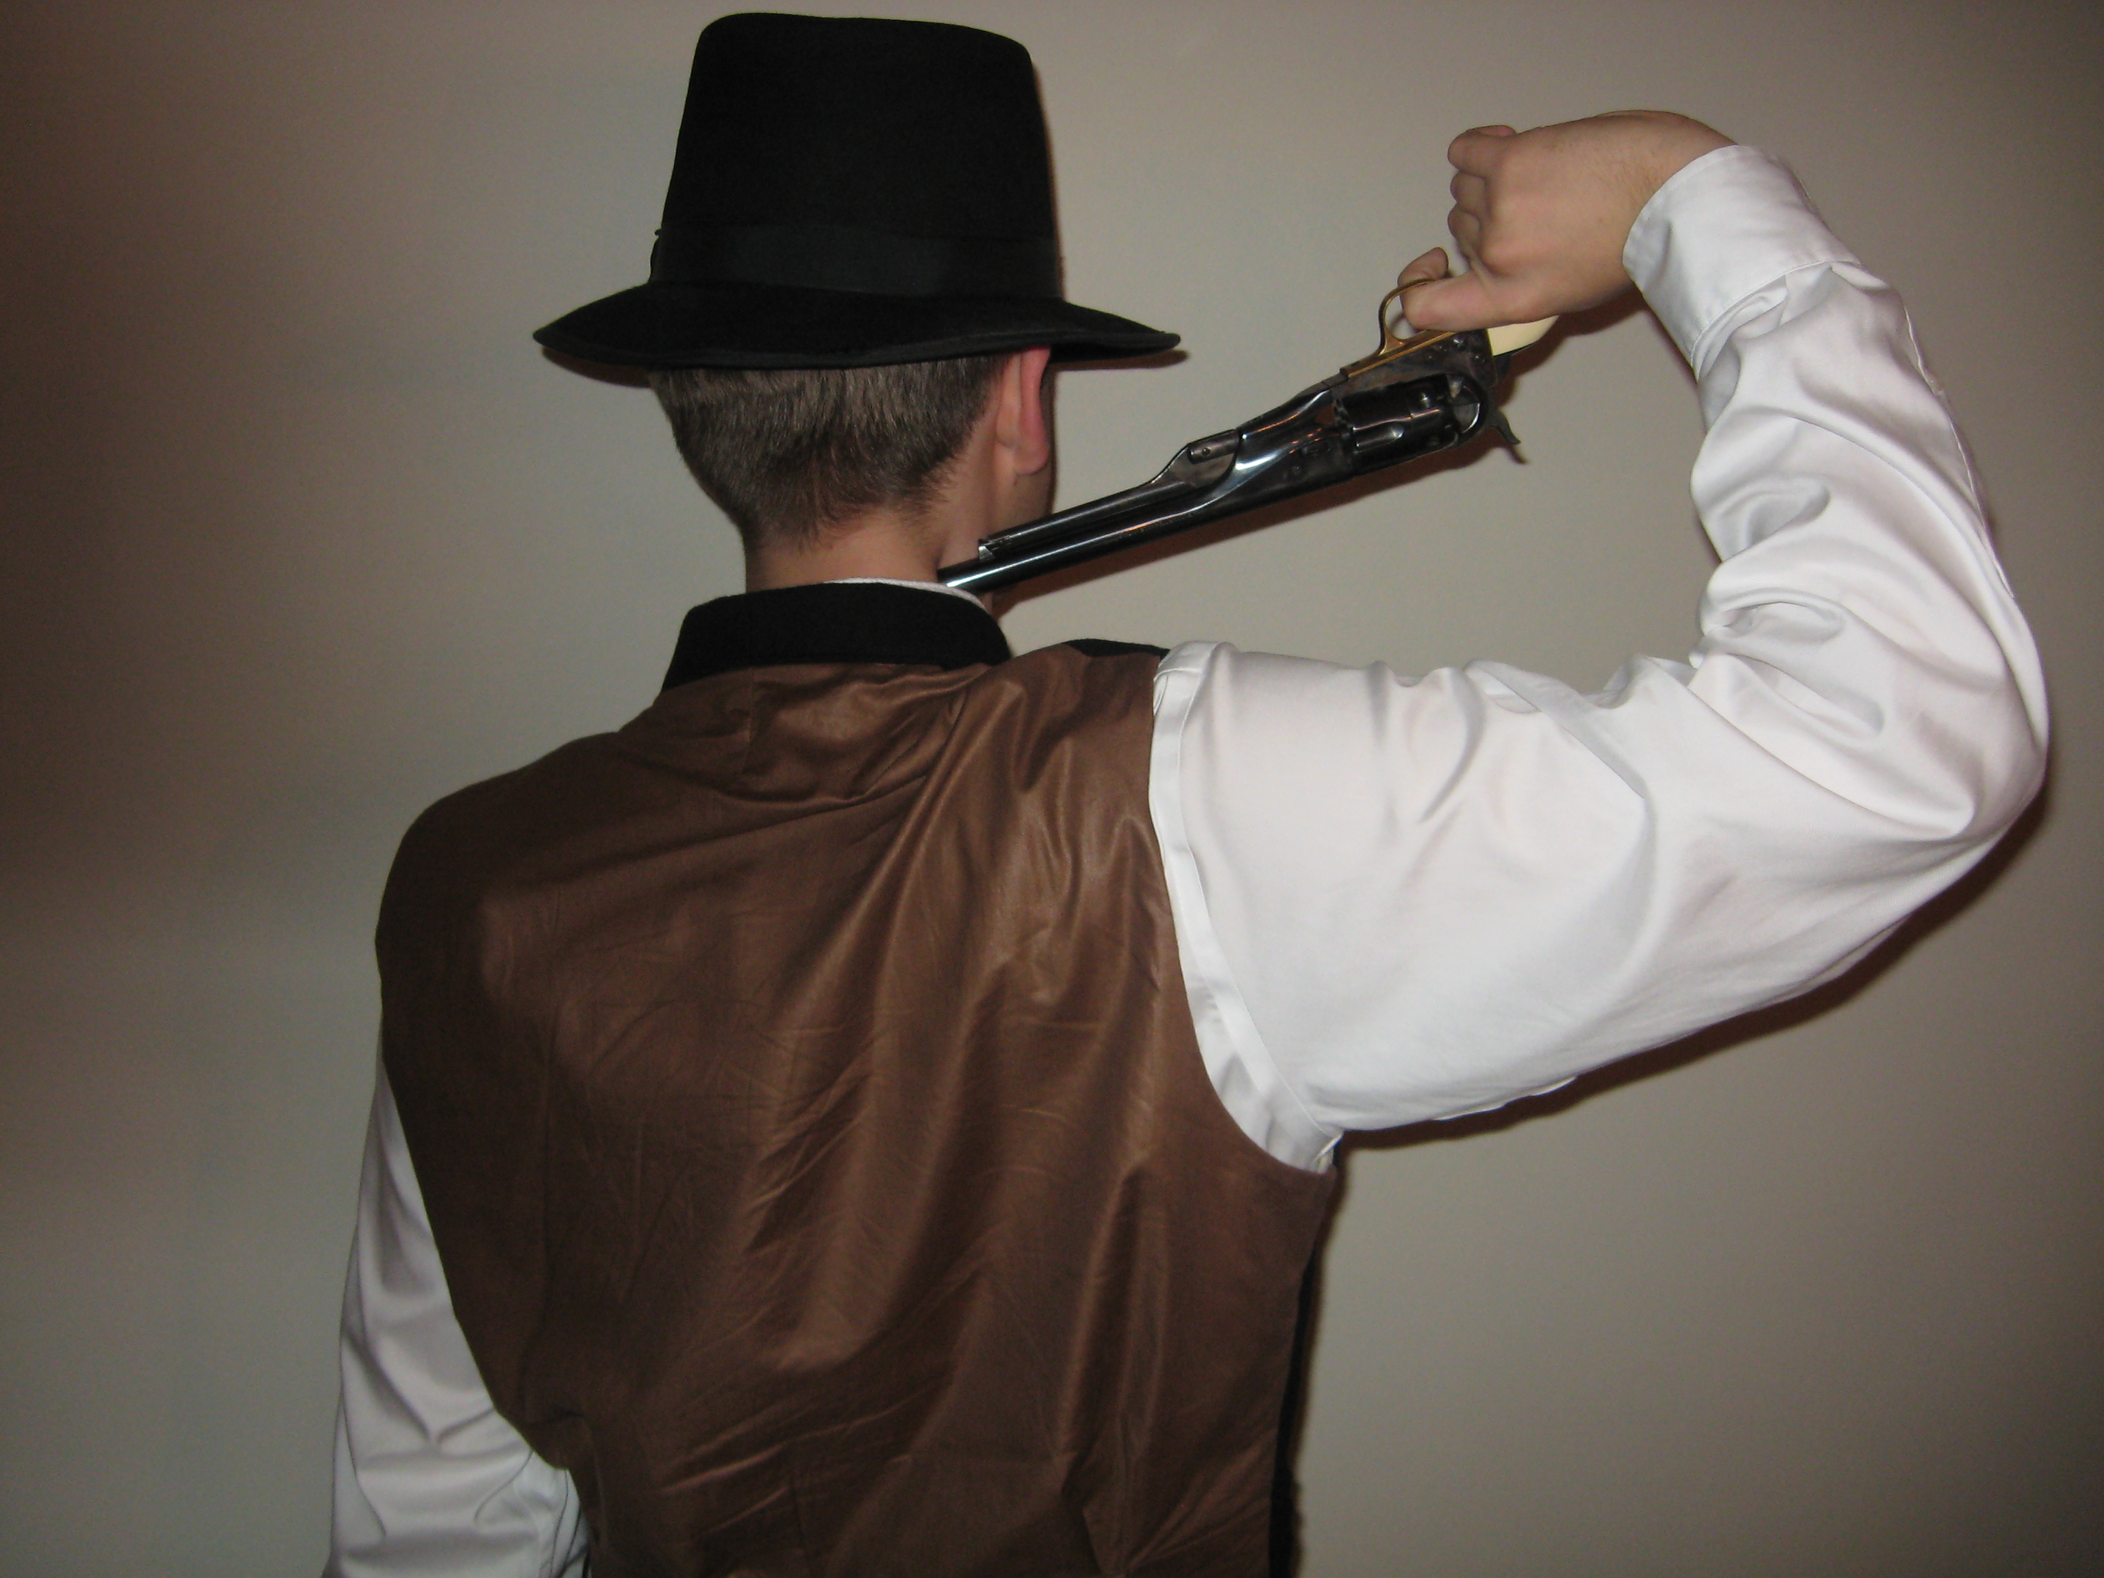

Lattimer also vetoes the notion that Booth could have committed suicide because the autopsy mentioned no powder burns or collateral damage a close shot would incur. He shot pork necks and left them exposed to the elements for thirty hours, just as Booth's body was before autopsy, to reach his conclusion. The problem here is that Booth's decaying body was already blackened and distended so badly that initially the first witness to see him (Dr. John F. May, who had removed the boil or cyst from his neck two years earlier), had trouble identifying his horrible visage. According to the Pima County (Arizona) medical examiner, consulted by us, under the right conditions, the body can blacken within twenty-four hours. It was very warm at the end of April 1865, and Booth's body was already in bad shape later on the day he was killed.
With humid weather, as in Virginia and Maryland, a dead body would tend to swell with retained fluids as it decays. Body decomposition does alter the shape and character of wounds. And it is also quite possible that experienced surgeons like Barnes and Woodward did not mention any marks of suicide, such as powder burns, not because they missed them, but because that is what Secretary of War Stanton instructed them to do. Further, forensic professionals say that gunpowder tattooing is left only when the weapon is not in contact with the skin. In any case, the possibility of suicide is neither ruled in nor out in the autopsy reports. As to the assertion that Booth's collar would have caught fire had he shot himself, one wonders if a gun barrel pressed tight to the body (see our photograph) might absorb such fire. Maybe his shirt had no collar (shirts made with detachable collars were a typical style of the time) to catch fire. It is another one of those things that was not mentioned in the autopsy reports. But Congressman and author David M. DeWitt emphasizes that Col. Conger thought that Booth "had the appearance of a man who put a pistol to his head and shot himself--shooting a little too low."
According to Lt. Baker, Booth no longer had the carbine, just a revolver in his hand, when Baker entered the barn after the shot rang out. Indeed, Baker said he had to twist the six-shooter out of Booth's iron grasp. But a man shot through the spinal cord as Booth had been (according to the autopsy report of Dr. J. Janvier Woodward, of the Army Medical Museum), would not be able to hold anything. According to the Pima County Medical Examiner, under the conditions described in the autopsy reports, Booth immediately would have been completely paralyzed from the neck (fourth vertebrae) down, as Barnes had reported. He would not have been rigid, but completely flaccid in his muscles and nerves--nothing functioning as it should. Booth would have dropped anything he was holding as the bullet severed his spinal cord. Lt. Baker either lied or exaggerated, possibly wanting to look like a daring man of action, or more worthy of a bigger share of the reward.
Regardless of whether Booth shot himself or someone else shot him, many, from Confederate Lieutenant M.B. Ruggles, one of those who took Booth to Garrett’s Farm, to modern historian Larry Starkey, questioned whether Sgt. Corbett actually did it. Others saw it otherwise. Otto Eisenschiml concludes that Conger shot Booth to stop him from incriminating Stanton or other unnamed persons of note, connected to the Federal government, in Lincoln’s assassination. We doubt that, but the fact remains that Booth was physically able to produce the wound that Lattimer maintained he could not. But we agree, as one investigator says in Lattimer’s study, if Booth shot himself, he did it in the back of the head to save his pretty face. As he raised the weapon to fire the shot which would take his life, his hand slipped and the shot cut his spinal cord instead of blowing his brains out--a final blow of the ill-fortune that had plagued all of his endeavors against Lincoln since January 1865.
The point of this study is just this: that it was absolutely possible for Booth to have shot himself in the manner we describe. Did he? No one knows. Did Corbett shoot Booth as he maintained? No one knows. And there the story must remain. The witnesses saw nothing; but everyone heard the shot. Historians and commentators may believe whatever they choose, but no one can prove anything except Booth died from a bullet through the cervical spine that produced paralysis, and, ultimately, his death.

Our thanks to Rick Stelnick for allowing us to reprint this paper which first appeared under his byline in Suite 101, Feb. 10, 2012.
Francis Wilson, John Wilkes Booth: Fact and Fiction of Lincoln’s Assassination (Boston: Houghton Mifflin Co., 1929), 180-82; Michael W. Kaufman, American Brutus: John Wilkes Booth and the Lincoln Conspiracies (New York: Random House, 2004), 321-23; Edward Steers, Jr., Blood on the Moon: The Assassination of Abraham Lincoln (Lexington: University of Kentucky Press, 2001), 203; James L. Swanson, Manhunt: The 12-Day Chase for Lincoln’s Killer (New York: HarperCollins, 2006), 334-35, 339-40; Bill O’Reilly, Killing Lincoln: The Shocking Assassination that Changed America Forever (New York: Henry Holt and Co., 2011), 275-76. Rob Wick, “Why Did Everton Conger Burn Down Richard Garrett’s Tobacco Barn?” Surratt Courier, 33 (May 2008), 6-7, theorizes that Col. Everton Conger was suffering from old war wounds on the extended ride to find Booth and wanted to get it over with posthaste. While not disagreeing with this analysis, we think that the fear that more Federal forces might arrive soon and dilute the reward money also had great influence in hastening the denouement.
On Boston Corbett, see Richard F. Snow, "Boston Corbett," American Heritage, 30 (June-July 1980), 48-49; and Laurie Verge, "The Killer of John Wilkes Booth," in Michael W. Kauffman (ed.), In Pursuit of . . . : Continuing Research in the Field of the Lincoln Assassination (Clinton, Md.: The Surratt Society, 1990), 111-12. Corbett's own intriguing tale is in Steven G. Miller (ed.), "Boston Corbett's Long-Forgotten Story of Wilkes Booth's Death," Surratt Courier, 26 (May 2001), 5-7; ibid., 26 (June 2001), 4-6.
U.S., 40th Cong., 1st Sess., 1867, House Reports, No. 7/2, “Impeachment: Testimony before the Judiciary Committee of the House of Representatives in the Investigation of the Charges against Andrew Johnson,” 323-33, 479-90. A good summary of the “Impeachment Testimony” as regards the shooting of Booth and the pursuers’ response is William L Reuter, The King Can Do No Wrong (New York: Pageant Press, 1958), 43-51. One of the better accounts, unfortunately unpublished, is Jeanine Clarke Dodels, "The Last Days of John Wilkes Booth," 15-28 (Unpublished and undated paper in the hands of Smith and Richter). The number of sources commenting on the death of Booth includes but is not limited to Jacob Mogelever, Death to Traitors: The Story of General Lafayette C. Baker, Lincoln's Forgotten Secret Service Chief (New York: Doubleday & Company, 1960), 357-60; Roy Z. Chamlee, Jr., Lincoln's Assassins: A Complete Account of their Capture, Trial, and Punishment (Jefferson N.C.: McFarland & Company Inc., Publishers, 1990), 155-57; Theodore Roscoe, Web of Conspiracy (Englewood Cliffs, N.J.: Prentice-Hall, 1959), 387-98; Osborn H. Oldroyd, Assassination of Abraham Lincoln: Flight, Pursuit, Capture, and Punishment of the Conspirators (Washington: O. H. Oldroyd, 1901), 70-78; Laughlin, Clara E. Death of Lincoln: The Story of Booth's Plot, His Deed and the Penalty (New York: Doubleday, Page & Co., 1909), Death of Lincoln, 147-53; George A. Townsend, Life, Crime, and Death of John Wilkes Booth, 32-39; Michael W. Kauffman, “Booth's Escape Route: Lincoln's Assassin on the Run,” Blue and Gray Magazine, 7 (June 1990)[Special Issue], 49-50; David Rankin Barbee, "Lincoln and Booth" (Unpublished ms. in the David Rankin Barbee papers, Georgetown University), 959-84, passim, DRB papers, GU.
Donald Winkler, Lincoln and Booth: More Light on the Conspiracy (Nashville: Cumberland House, 2003), 189-93.
Ingraham, Prentiss (ed.), “Pursuit and Death of John Wilkes Booth,” The Century Magazine, cited in Steven G. Miller, “Death of an Assassin: Homicide, Suicide, or Something Else,” in Lincoln-Assassinztion.com, splash page. The full citation is: The Century Magazine, 39 (No. 3, January 1890), 443-49, with Booth’s desire not to be taken alive and Confederate Lt. M.B. Ruggles’ belief that Booth killed himself rather than be captured on 446.
Reuter, The King Can Do No Wrong, 47, 53-55
Quoted in Steven G. Miller, “Death of an Assassin: Homicide, Suicide, or Something Else,” in Lincoln-Assassination.com, splash screen, as of Feb. 28, 2012. Miller has looked at approximately 55 accounts of the shooting at Garrett’s farm and finds Parady’s story to be the only independently and marginally reliable (in our estimation, not Miller’s) one beyond Corbett’s own self-serving tale. Miller to Richter, November 26, 2011, e-mail in the author’s file.
Reuter, The King Can Do No Wrong, 46-51.
Robert A. Fowler, “Album of the Lincoln Murder: Illustrating How It Was Planned, Committed, and Avenged,” Civil War Times Illustrated, 4 (No 4, July 1965), 49.
Besides Winkler’s treatment, this is a main thesis of Joseph E. “Rick” Smith and William L. Richter, In the Shadows of the Lincoln Assassination: The Life of Confederate Spy Thomas H. Harbin (Laurel, Md.: Burgundy, 2007), 119-40. See also, Kate H. Mason, “A True Story of the Capture and Death of John Wilkes Booth,” Northern Neck Historical Magazine, 13 (December 1963), 127-39, and J. Sydnor Massey, “Chapter in the Death Chase of John Wilkes Booth,” Richmond Times-Dispatch, April 12, 1905, reprinted in Lincoln Assassination Discussion, General Category, All Things Lincoln Assassination, Enoch Mason’s Story of the Last Days of Booth” (Lincoln-Assassination.com).
Dr. Blaine V. Houmes and Steven G. Miller, “The Death of John Wilkes Booth: Suicide by Cop?” American Journal of Forensic Psychiatry, 25 (No. 2, 2004), 25-36. See also, Miller’s most recent effort in this matter, “Death of an Assassin: Homicide, Suicide, or Something Else,” in Lincoln-Assassination.com, splash page, and Miller (ed.), a modernization of James O. Hall, “A Case of Mistaken Identity,” in Occasional Papers, 1 (no. 1, November 2011), 35-48.
James L. Swanson, Manhunt: The 12-day Hunt for Lincoln’s Killer (New York: Harper Perennial, 2006), 330-31. Rollin G. Osterweis, Romanticism and Realism in the Old South (Baton Rouge: Louisiana State University Press, 1967), explains the Southern propensity to romantic callings. For Booth’s tendency in this direction, see his letters to T. William O’Laughen in John Rhodehammel and Louise Taper (eds.), “Right or Wrong, God Judge Me”: The Writings of John Wilkes Booth (Urbana: University of Illinois Press, 1997), 35-44, especially 37-39.
Osterweis, Romanticism and Realism, 3-57. Booth’s challenge to the Federal soldiers is straight out of the Old South and the Code Duello. See, e.g., Joanne B. Freeman, Affairs of Honor: National Politics in the New Republic (New Haven: Yale University Press, 2000), Bertram Wyatt-Brown, Southern Honor: Ethics and Behavior in the Old South (New York: Oxford University Press, 1982), and Elliott J. Gorn, “Gouge, Bite, Pull Hair and Scratch: The Social Significance of Fighting in the Southern Backcountry,” American Historical Review, 90 (1985), 18-43.
Rhodehammel and Taper (eds.), The Writings of John Wilkes Booth, 155.
John K. Lattimer, Kennedy and Lincoln: Medical and Ballistic Comparisons of Their Assassinations (New York: Harcourt, Brace, Jovanovich, 1980), 61-84.
Ibid., 79
On Booth’s familiarity and skill with revolvers, see testimony of Benjamin Barker, War Department Records, Judge Advocate General, National Archives and Records center as excerpted in David Rankin Barbee papers, folder 216, box 4, Georgetown University.
Lattimer, Kennedy and Lincoln, 78-83.
See John F. May, "The Mark of the Scalpel," Records of the Columbia Historical Society, 13 (1910), 49-68.
David Miller DeWitt, Assassination of Abraham Lincoln (New York: Macmillan, 1909), 90.
Lattimer, Kennedy and Lincoln, 75.
Ibid., 69-70.
See also, the autopsy report of Surgeon General J. K. Barnes, in Laurie Verge (ed.), The Body in the Barn: The Controversy Over the Death of John Wilkes Booth (Clinton, Md.: The Surratt Society, 1993). 67-68.
Ingraham, Prentiss (ed.), “Pursuit and Death of John Wilkes Booth [Ruggles’ story],” 446; Larry Starkey, Wilkes Booth Came to Washington (New York: Random House, 1976), 146-49, especially 147.
The best narrative of what happened at Garrett’s Farm is Dodels, “The Last days of John Wilkes Booth at the Garrett Farm” who adopts the Corbett story without question. See also, Otto Eisenschiml, "Who Shot Booth?" in O. E.: Historian Without an Armchair (Indianapolis: Bobbs-Merrill, 1963), 159-66. Eisenschiml’s theory has gone “viral” since its inception; see Fowler, Robert H. "Was Stanton behind Lincoln's Murder?" Civil War Times, 3 (Aug. 1961), 4-13, 16-23; and David Balsiger and Charles E. Sellier, Jr., The Lincoln Conspiracy (Los Angeles: Schick Sunn Classic Productions, 1977). The Lincoln Conspiracy was also made into a television special and a full-length movie.
Lattimer, Kennedy and Lincoln, 75.

